|  |  |
| --- | --- |
|  | Department of Masters of Computer Applications School of Computer Science and IT,  Jain Knowledge Campus  #44/4 District Fund Road Jayanagar, 9th Block Behind Big Bazaar, Bengaluru, Karnataka-560069 |

**PROJECT TITLE:**

**BUS RESERVATION SYSTEM**

**TEAM MEMBERS: -**

|  |  |  |
| --- | --- | --- |
| 01. | 21MCAR0106 | JINOY VARGHESE |
| 02. | 21MCAR0091 | ABHISHEK ANILKUMAR |
| 03. | 21MCAR0126 | ROSHAN SHAJU |

**Under supervision of: -**

**Dr. Ganesh D**

**Associate Professor**

**Bus Reservation System**

**Introduction:**

The Online Bus Reservation System is a web-based application that allows visitors check bus ticket availability, buy bus ticket and pay the bus ticket online. Online Bus Reservation System provides bus transportation system, a facility to reserved seats, cancellation of seats and different types of enquiries which need an instant and quick reservation. This system can be used by the users in performing online reservation via internet for their all business purposes. Users can use this program directly on their browsers and no need to install it. The use of bus traveling is a large growing business in India and other countries; hence bus reservation system deals with maintenance of records of each passenger who had reserved a seat for a journey. It also includes maintenance of information like schedule and details of each bus. Also, we get to know that there are many operations, which they have to do manually. It takes a lot of time and causes many errors. Due to this, sometimes a lot of problems occur and they were facing many disputes with customers. To solve the above problem, and further maintaining records of items, seat availability for customers, price of per seat, bill generation and other things, we are offering this proposal of reservation system. The reservation system has three modules. First module helps the customer to enquire the availability of seats in a particular bus at particular date, the second module helps him to reserve a ticket and with the third module he can cancel a reserved ticket. Bus Ticket Reservation System enables the customer to buy bus ticket, make payment, and ask for information online easily. Furthermore, staff can sell bus ticket using Bus Ticket Reservation System after check bus ticket availability for the customer and print the bus ticket to the customer that queue up in the counter. The method to solve this problem is to create an online buying bus ticket system. Customer can buy the bus ticket over the Internet, 24 hours a day, 7 days a week and the bus ticket can't be lost, stolen or left behind. In addition, the online system lets the customers check the availability of the bus ticket before they buy bus ticket. Furthermore, customers no need to pay cash to buy bus ticket because they can pay the bus ticket by using deposit slip number order by bank.

# Problem Statement:

In transport companies, most of the driver information is kept in file. Therefore, it is quite hard for them to search the driver information when needed. Moreover, it uses a lot of papers and data is lost because of no backup provided for the data. Some of the data is quite hard to read because the form was filled up by hand writing. Another problem is that the people living in remote areas have to come to the town or city to for booking seats, which is a very tedious task.

# Objectives:

The main objective of the Bus Reservation System are as follows:

1. To develop a simple and secure system that protects client’s information and confidential information of the organization.
2. To design a user-friendly system that enables client check for availability of Bus and book or reserve a Bus Ticket online.
3. To design a system that enables clients pay their car fare online.
4. To develop a system that stores bookings and reservation information as well as payment history to help the organization keep track of transactions.
5. To reduce the time taken through manual system in order to maintain the records.
6. It will help the people in remote areas for booking their seats easily in any buses.

**MODULE DESCRIPTION**

The modules included in this system are:

1. Admin

* Make reservation
* Cancel reservation
* Print ticket
* Login
* Update payment
* Manage users
* Manage buses
* Update profile

1. Bus Owner

* Add staff
* Login
* Update route
* Update payment
* Update bus details

1. Staff

* Check passenger tickets
* Login

1. Passenger

* Bus availability enquiry
* Login
* Make reservation
* Cancel reservation
* Make payment
* Print ticket
* Create invoice

# Traditional System Vs Bus Reservation System:

Difference between traditional system and proposed system is as follows:

|  |  |  |
| --- | --- | --- |
|  | **Traditional System** | **Proposed System** |
| **Vehicle Selection** | You have to ask your needs verbally | You can check online and go with your favourite choice. |
| **Compare The Rate & Fuel Policy** | You have to go to any bus stand physically to know about the rate. | You can compare their rates and other terms online.. |
| **Knowledge Before Hire** | Buying tickets from the conductor for commuting to and fro from a location through public transportation. | No need to communicate with conductor for buying tickets. |
| **Payment** | Need to pay by cash. | Can pay through online. |

# Traditional Systems:

The current bus booking system relies on buying tickets from the conductor for commuting to and from a location through public transportation . The task can be tedious if the number of commuters is large. Also, payment in cash can be difficult if the payable denominations are uneven. Online Bus Booking system allows the computer to either have a specific amount of money on his Android Based mobile, from which the ticket can be charged. Or, the commute can buy the ticket on the bus.

# Disadvantages of the Existing System:

* 1. It is difficult to track the occupancy.
  2. More manual hours needed to generate required reports.
  3. It is tedious to track bus location.
  4. There is no possibility to track the approvals of requests.
  5. Can only pay by cash in hand.

# Proposed System:

Proposed system is a software application which avoid more manual hours that needs to spent in record keeping and generating reports. This application keeps the data in centralized way which is available to all the users simultaneously. It is very easy to manage historical data in database. No specific training is required for the employee to use this application. They can easily use the tool that decreases manual hours spending for normal things and hence increases the performance.

Bus ticket booking during the offline era posed various difficulties to the customers as well as the bus operators. Offline ticket booking reduced the scope of customers to choose different options based on their travel criterion. It also increased the franchising cost for the bus operators. At the same time, the bus operators were also finding it difficult to monitor their bus seat filling information. Many small and medium bus service organizations do not have their own online bus ticket booking system. It also offers the power of decision making to customers to make a ticket booking through bus operators’ popularity, performance and ranking.

# Features:

1. Capture of customer information such as name, address, phone number and e-mail address.
2. Price list.
3. Bus operators ranking.
4. Seating chart.
5. Loyalty Points/Redemption.
6. Payment information.
7. Organization's advertisement/slogan, phone number, fax number, and address.
8. Comments and suggestions section / option.
9. Report

# Functional Requirements :

1. Arrival date
2. Departure Date
3. Number of buses available
4. Payment Method
5. Number of seats available
6. Coupons
7. Customer Profile with address
8. Bus Tracking

# Non-Functional Requirements :

1. Performance
2. Scalability
3. Capacity
4. Maintainability
5. Implementation Requirement
6. Usability Requirement

**Use Case Diagrams**

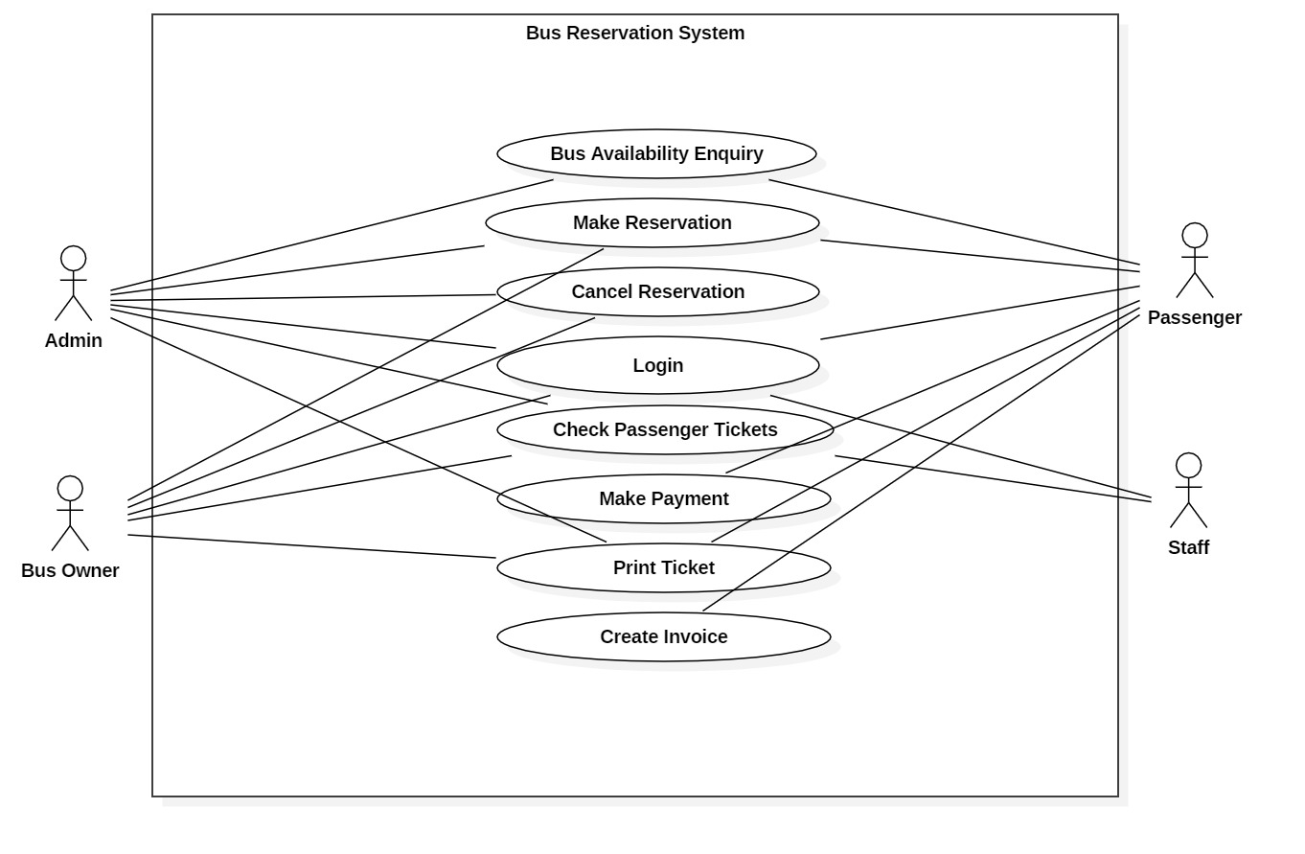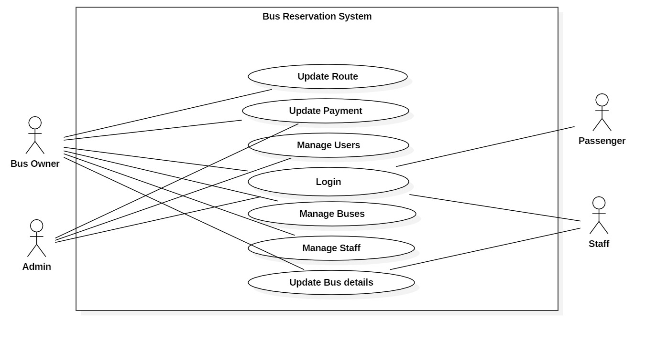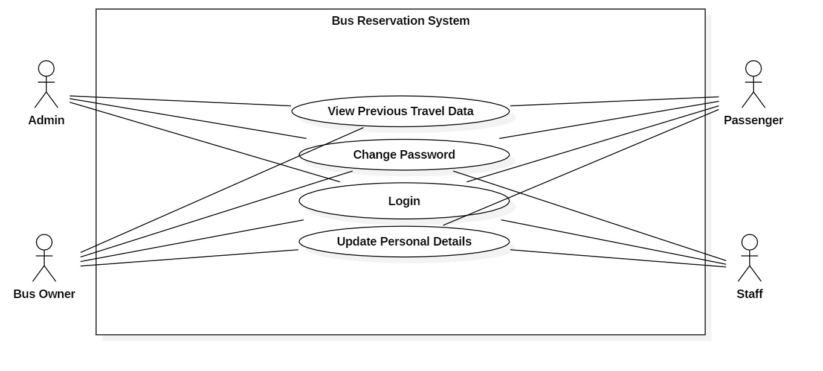

**Class Diagram**

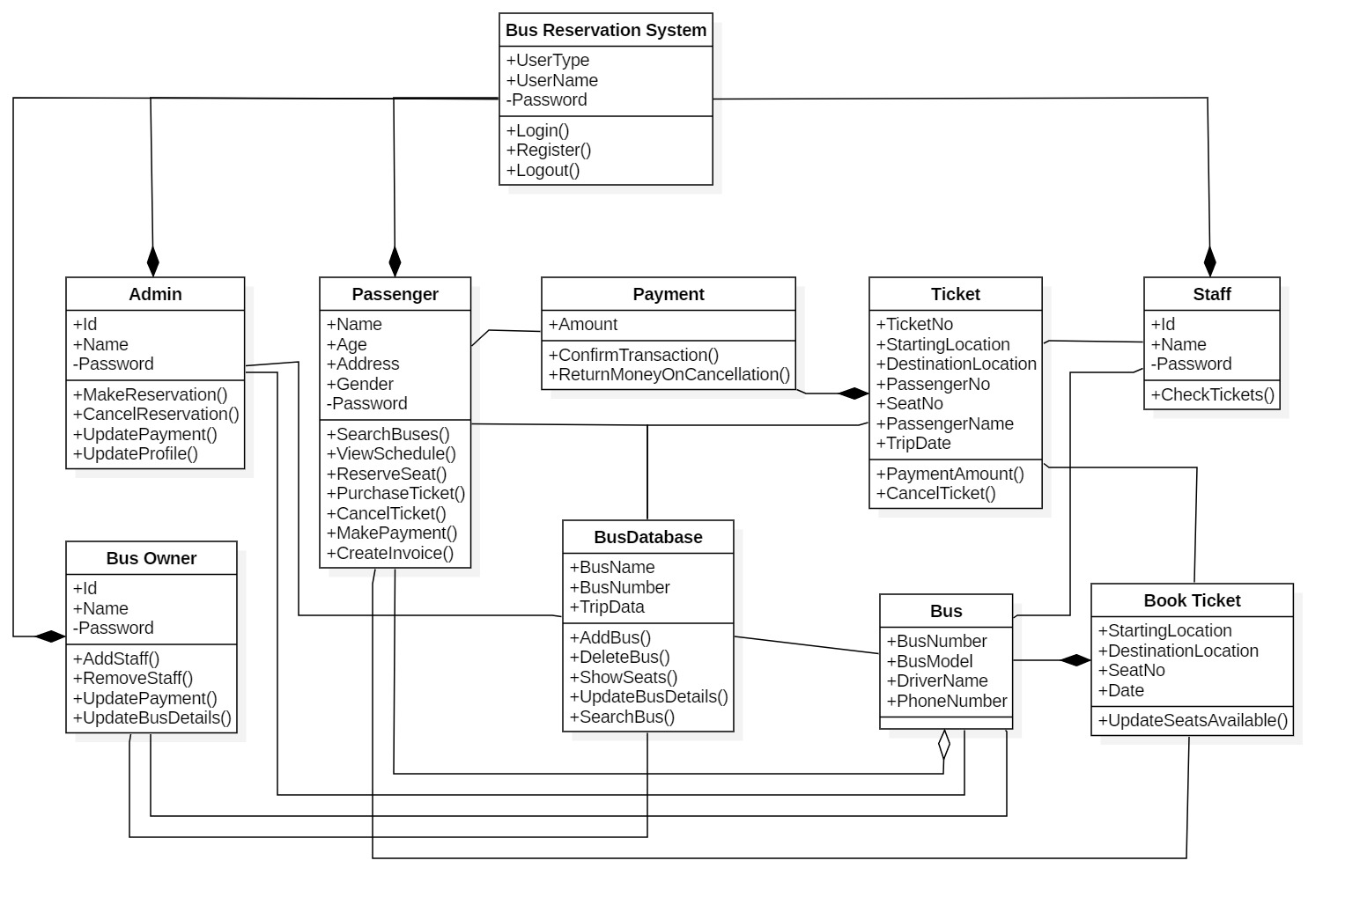

**SELECTION OF TOOLS (S/W, H/W REQUIREMENT)**

**Minimum Hardware Requirements**

Processor : Intel(R) i5 CPU

RAM : 4GB

Hard Disk : 512 GB

Keyboard : Standard 101/102 key

Mouse : Optical mouse

Printer : Ink jet

**Software Specification**

Operating System : Windows 10

Front End : HTML5, CSS and JS

Back End : PHP, MySQL and MongoDB

Browser : Any browser with HTML5 support

**System Testing**

Testing is the process of executing a program with the intent of finding any errors. A good

test of course has the high probability of finding a yet undiscovered error. A successful testing is the one that uncovers a yet undiscovered error. A test is vital to the success of the system. System that makes logical assumptions that if all parts of this system are correct, then foal will be successfully achieved. The candidate system is subjected to variety of tests online like responsiveness, its value, stress and security. System testing can be broadly classified into:

1. Black box testing
2. White box testing
3. Unit testing
4. Integration testing
5. Validation testing

**Black Box Testing**

When computer software is considered b1ack box testing alludes to tests that are conducted at the software interface. A black box test examines some fundamental aspects of a system with little regard for the internal logical structure of the software. Black box testing attempts to find errors in the following categories:

1. Incorrect or missing function
2. Interface errors
3. Performance errors
4. Errors in data structures or external database access
5. Initialization and termination errors

In our application, we use a number of functions to perform operations. Using the black

box testing, we made sure that all functions are executing correctly by giving the required result.

**White Box Testing**

It is a testing method that uses control structure of procedural design to derive testing.

Knowing the internal working of a product tests can be conducted to ensure that the internal

operations perform according to specification and all internal components have been adequately exercised. White box testing of software is predicated on close examination of conditions and/or loops tests logical paths through the software. Using this testing method, the software engineer can do tests that:

Guarantee that all independent paths within a module have been exercised at least Once.

1. Exercise all logical decisions on their true and false values.
2. Execute all loops at their boundaries and within their operational bounds.
3. Exercise internal data structures to ensure their validity.

Here all logical structures are tested in their true and false conditions. We also made

sure, that all loops are performing well at their boundaries. For the checking appropriate data inputs are given and they are processed correctly. Individual functions are tested separately for each of the above conditions.

**Unit Testing**

This is the first level of testing. Here different functions used in the software development

are split into different modules and tested to see whether they satisfy our needs. Code produced during the coding phase of the software development process and the internal logic of the module is tested here. After coding each function was tested individually. The logical errors found were corrected.

**Integration Testing**

This is systematic technique for constructing the structure while conducting tests to

uncover errors with interfacing. Here the different functions of software are combined into sub system, which are again tested. The various unit tested functions of the software were integrated and rigorous integration testing was conducted to make the application free of any interface errors that may occur. In this phase various functions are combined. Once the individual functions were tested, we tested the control hierarchy in a top down integration manner.

**Validation Testing**

It provides the final assurance that the software meets all functional, behavioral and

performance requirements. Then software changed for the better performance. When the

application was made free of all logical and interface errors, validation testing was conducted by inputting dummy data to ensure that the software developed satisfied all the requirements of the user. This includes providing various valid and invalid inputs.

System tests carried out to validate dully developed system with a view assuring that it

meets its requirements. There are essentially three kinds of system testing:

**1.Alpha Testing**

It refers to the system testing that is carried out by the test team within the organization.

**2. Beta Testing**

Beta testing is the system testing performed by a selected group of friendly customers.

**3.Acceptance Testing**

Acceptance testing is the system testing performed by the customer to determine whether

or not to accept the delivery of the system. The application is tested to ensure the requirements. Different sets of input data are entered to validate the system. In all cases the system produces the reasonable output.

**Deployment Diagram**

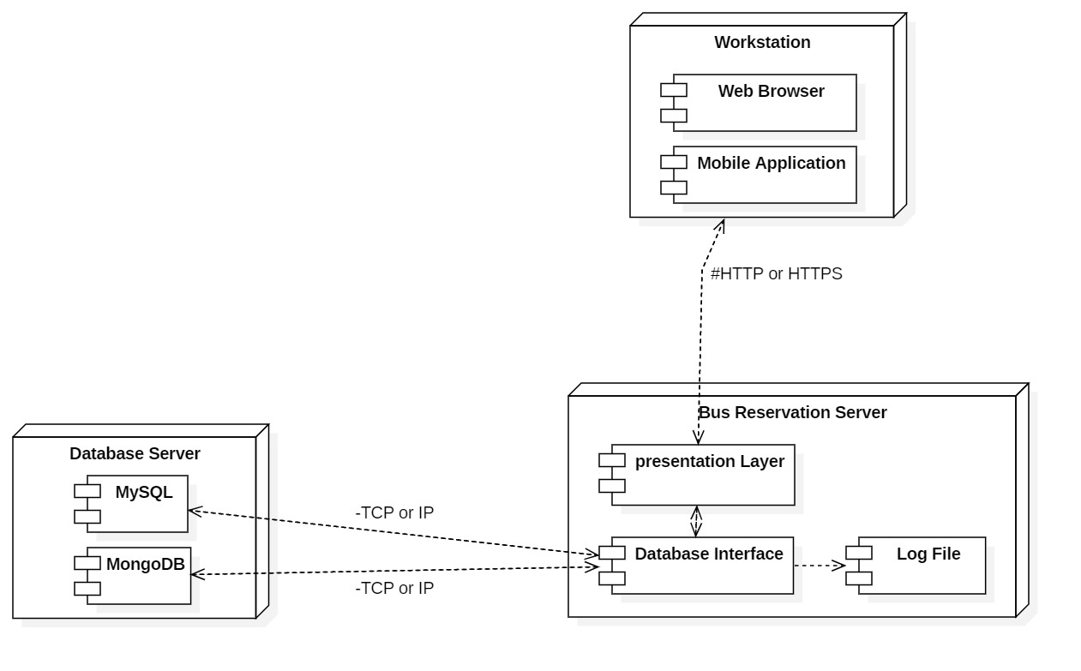

**SECURITY MECHANISMS**

This project provides some security features. We can implement application security in

the developing system. After registering details, they have to authenticate by providing the

appropriate username and password. Securities are provided in this project that the data remains confidential. We can implement security in two ways, through passwords and through the limitations in the access rights. Password facility is implemented to avoid unauthorized access of information. For providing more security they have to change their passwords with their wishes. And it is more secure to change password periodically and it must be kept confidentially. A combination of alphabets, numbers and special characters make a password strong.

**UPGRADABILITY POSSIBILITIES**

The technology is changing day to day. The efficiency of developed system can be

improved by modifications. The quality of this online site can be improved by keeping wise list of reports and other documents effectively. So it is easy to add or remove modules. Software development in PHP is very flexible and all application was tested with live data and has proved respond successful. So it is quite and helps in smooth migration from manual system to computerized system. Our project BUS RESERVATION SYSTEM is a project that contain only five modules such as administrator, employee, registered user, and guest user. It is easy to develop and upgrade. It is compatible with any future developments.

**CONCLUSION**

The new system has overcome most of the limitations of the existing system and works

according to the design specification given. The developed systems dispense the problem and meet the needs of by providing reliable and comprehensive information. All the requirements projected by the user have been met by the system. The newly developed system consumes less processing time and all the details are updated and processed immediately. since the screen provides online help messages and is, very user-friendly, any user will get familiarized with its usage. Modules are designed to be highly flexible so that any failure requirements can be easily added to the modules without facing many problems.